


Data Compliance Test (DCT)
Test Cases for
Adverse Drug Reaction Record

<HCP Name>

Table of Contents
1. Testing Instructions to HCPs 3
1.1 Self-Service Testing Phase 3
1.2 Final Testing Phase 3
1.3 Preparation DCT Test Report 4
2. Test Case Details 5
ADR-001 5
ADR-002 10
3. Appendix – Sample Messages 14
4. Appendix – Testing HCP and HCRs Information 16
5. Appendix – Sample Results in eHR Viewer (EVE) 17
6. Appendix – Actual Data Values (Sample) 19

Testing Instructions to HCPs

Self-Service Testing Phase
- After development of the data upload programmes, you can use the Self-Service test accounts and test HCRs provided by eHealth for connection to the eHealth testing environment and proceed with the self-service testing.
- You can proceed with the Self-service test at your own pace by following this Self-Service Testing Guide and using the test cases provided in section 2.
- You can verify the correctness and completeness of the data upload by:
  - checking the interface files / messages generated in your system against the sample expected results of interface files /messages for all test cases as provided;
  - checking the results on eHR Viewer (EVE) by logging into the testing eHealth with the provided test account; and
  - checking the upload status through Process Summary and Exception Report in eHR Inbox by logging into the testing eHealth.
- For data fields requiring eHR Codex values, you can refer the Code Sets provided with the Self-Service Kit.
- For details of technical requirements of the data interface files, please refer to the ‘Developer Quick Guide for Adverse Drug Reaction Data Upload to eHealth.docx’.
- You are required to perform the test cases that are relevant to the data compliance level supported by your clinic.
- You are required to perform the first batch of data upload by Data Materialization (DM) mode. DM mode is denoted in the interface by a fixed value BL-M in HL7 OBX.4
- You should use Incremental Load (INC) mode for the second batch of data upload to update the previously uploaded records. INC mode is denoted in the interface by a fixed value BL in HL7 OBX.4.
- Since the DM mode would replace the corresponding records previously uploaded to eHealth, you may repeat your testing unlimited number of times by uploading the first batch by DM mode.
- It should be noted that the data field “Record Key” should be unique for each adverse drug reaction record, while each adverse drug reaction record can carry multiple adverse drug reaction causative agents.
- When all required test cases can be completed smoothly and correctly in this phase, you can proceed to the Final Testing Phase and submit production environment setup form to eHR DCT Support for preparation.

Final Testing Phase
- You can start the Final Testing Phase once all test cases in the Self-Service Testing phase are passed.
- You should start Final Test by executing the test cases provided in section 2 with Final Testing HCRs provided by eHR DCT Support.
- You can verify the correctness and completeness of testing results by checking results in eHR Viewer (EVE) and the upload status through Process Summary and Exception Report in eHR Inbox.
- For Adverse Drug Reaction DCT test cases, there are TWO batches of data files / transactions to be uploaded to the testing eHealth. The required records must be correctly uploaded from these 2 consecutive batches respectively.
- The Final Test will be considered PASSED if all the following criteria are met:
  - The TWO batches of test data files are uploaded consecutively in the correct sequence. The second batch of data files/transactions must be submitted after completion of processing of the first batch by eHealth.
  - No additional data files / transactions are uploaded in between or after the uploads of the above two batches of data files / transactions to amend any records.
  - No exception records are reported from the uploads.
  - No manual interventions have been made to the data files / transactions.
- If the Final Test failed, you can re-attempt the Self-Service Test and Final Test until a successful run can be completed.

Preparation DCT Test Report
- Once you have successfully passed the Final Test based on the above criteria, you should complete this document by attaching the below items to this document at the appropriate space provided:
  - Actual data files uploaded
  - Screen-shot of each test case
- You are required to submit this completed ‘DCT Test Cases’ document to eHR DCT Support for further processing. eHR DCT Support will provide feedback within 10 working days.

Test Case Details
1 | Test Case ID | ADR-001
 | Function Description | HCP has received the sharing consents from testing HCRs, then perform first data upload of HCRs’ clinical records to eHealth by DM Mode.
 | Subsequent case of | N/A
 | Testing Assumption | - HCR1-HCR8 have already given sharing to sharing consent to your outpatient clinic.  - The eMR system (EMRS) will upload Batch 1 data files to eHealth with all adverse drug reaction records of <HCR1> - <HCR8> created by DM mode.
 | Test Actions | HCP creates below adverse drug reaction records in eMR system:  For level 3 data, please perform test cases 1a – 1e  For level 2 data, please perform test cases 1f – 1h.
 | Test Actions | 1a | (Level 3 data) Input in the HCP’s EMRS an adverse drug reaction record ‘Penicillins’ with ‘Vomiting’ reaction for <HCR1>. The clinical record uploaded to eHealth should contain the follows:  - Adverse drug reaction causative agent - recognised terminology name = HKCTT  - Adverse drug reaction causative agent identifier - recognised terminology = 7002240  - Adverse drug reaction causative agent description - recognised terminology = Penicillins  - Adverse drug reaction causative agent local code = (Optional)  - Adverse drug reaction causative agent local description = Description used in the EMRS e.g. Penicillins  - Level of severity code = S  - Level of severity description = Severe  - Level of severity local description = Description used in the EMRS  - Adverse drug reaction description = Vomiting  - Adverse drug reaction causative agent remark = (Blank)  == Actual data values (Refer to “Appendix - Actual Data Values (Sample)” for details)  Note: For HCPs using only RPP in local system, please upload a drug from the penicillins group.
 | Test Actions | 1b | (Level 3 data) Input in the eMRS an adverse drug reaction record ‘aminophylline’ with ‘Vomiting’ reaction for <HCR2>. The clinical record uploaded to eHealth must contain the follows:  - Adverse drug reaction causative agent - recognised terminology name = HKCTT / RPP  - Adverse drug reaction causative agent identifier - recognised terminology = 6010636 / 53168  - Adverse drug reaction causative agent description - recognised terminology = Aminophylline / ASMETON "STRONG" CAP (CHINA)  - Adverse drug reaction causative agent local code = (Optional)  - Adverse drug reaction causative agent local description = Description used in the EMRS e.g. Aminophylline  Please provide below optional data field(s) (if applicable)  - Level of severity code = M  - Level of severity description = Mild  - Level of severity local description = Description used in the EMRS  - Adverse drug reaction description = Vomiting  == Actual data values (Refer to “Appendix - Actual Data Values (Sample)” for details)
 | Test Actions | 1c | (Level 3 data) Input in the eMRS an adverse drug reaction record ‘Calamine + Zinc Oxide’ with “Itchiness” reaction for <HCR3>. The clinical record uploaded to eHealth must contain the follows.  - Adverse drug reaction causative agent - recognised terminology name = HKCTT / RPP  - Adverse drug reaction causative agent identifier - recognised terminology = 6004172 / 66422  - Adverse drug reaction causative agent description - recognised terminology = Calamine + Zinc Oxide / CALACARE LOTION  - Adverse drug reaction causative agent local code = (Optional)  - Adverse drug reaction causative agent local description = Calamine + Zinc Oxide  - Level of severity code = M  - Level of severity description = Mild  - Level of severity local description = Description used in the EMRS  - Adverse drug reaction description = Itchiness  - Adverse drug reaction causative agent remark = Feel itchy over the body  == Actual data values (Refer to “Appendix - Actual Data Values (Sample)” for details)  Remark: Allergen remark would be shown when mouse-over the “i” button (i.e. information button). Screen capture of showing the allergen remark is required.
 | Test Actions | 1d | (Level 3 data) Input in the eMRS an invalid recognised terminology for <HCR4>: an adverse drug reaction record ‘Voltaren’ with ‘Nausea’ reaction. The incorrect recognised description highlighted in RED below should be set up (override the correct description) in the EMRS beforehand just for this test case and should be reverted to the correct description afterwards. The clinical record uploaded to eHealth would contain the follows:  - Adverse drug reaction causative agent - recognised terminology name = HKCTT / RPP  - Adverse drug reaction causative agent identifier - recognised terminology = 6000032 / 00170  - Adverse drug reaction causative agent description - recognised terminology = Voltaren 123 / VOLTAREN TAB 25 MG ENTERIC COATED 123  - Adverse drug reaction causative agent local code = (Optional)  - Adverse drug reaction causative agent local description = Description used in the EMRS e.g. Voltaren (diclofenac sodium)  Please provide below optional data field(s) (if applicable)  - Level of severity code = M  - Level of severity description = Mild  - Level of severity local description = Description used in the EMRS  - Adverse drug reaction description = Nausea  == Actual data values (Refer to “Appendix - Actual Data Values (Sample)” for details)  Remark: Since the Adverse drug reaction causative agent recognized terminology description is not matched with the one in HKCTT, this record will be re-graded to level 2 adverse drug reaction record and expected to be found in re-grade report.
 | Test Actions | 1e | (Level 3 data) Input in the eMRS a free-text adverse drug reaction record ‘Altagesic ointment’ with ‘Nausea’ reaction for <HCR5>. The clinical record uploaded to eHealth must contain the follows:  - Adverse drug reaction causative agent local code = (Optional)  - Adverse drug reaction causative agent local description = Altagesic ointment  Please provide below optional data field(s) (if applicable)  - Level of severity code = S  - Level of severity description = Severe  - Level of severity local description = Severe  - Adverse drug reaction description = Nausea  == Actual data values (Refer to “Appendix - Actual Data Values (Sample)” for details)  Remark: Record will be shown in “Re-grade Report” as Adverse drug reaction causative agent - recognised terminology data fields are blank.
 | Test Actions | 1f | (Level 2 data) Input in the eMRS a free-text adverse drug reaction record without recognised terminology for <HCR6>: an adverse drug reaction ‘Altagesic ointment’ with ‘Nausea’ reaction. The clinical record uploaded to eHealth would contain the follows:  - Adverse drug reaction causative agent local code = (Optional)  - Adverse drug reaction causative agent local description = Altagesic ointment  - Level of severity local description = Severe  - Adverse drug reaction description = Nausea  == Actual data values (Refer to “Appendix - Actual Data Values (Sample)” for details)
 | Test Actions | 1g | (Level 2 data) Input in the eMRS an adverse drug reaction record without recognised terminology for <HCR7>. An adverse drug reaction to ‘Augmentin’ with ‘Vomiting’ reaction. The clinical record uploaded to eHealth would contain the follows  - Adverse drug reaction causative agent local code = (Optional)  - Adverse drug reaction causative agent local description = Augmentin  - Level of severity local description = Mild  - Adverse drug reaction description = Vomiting  - Adverse drug reaction causative agent remark = Vomiting for few days  == Actual data values (Refer to “Appendix - Actual Data Values (Sample)” for details)  Remark: Adverse drug reaction causative agent remark would be shown when mouse-over the “i” button (i.e. information button). Screen capture of showing the allergen remark is required.
 | Test Actions | 1h | (Level 2 data) Input in the eMRS an adverse drug reaction record without recognised terminology for <HCR8>. An adverse drug reaction to ‘Pantoloc’ with ‘Diarrhea’ reaction. The clinical record uploaded to eHealth would contain the follows:  - Adverse drug reaction causative agent local code= (Optional)  - Adverse drug reaction causative agent local description = Pantoloc  - Level of severity local description = Mild  - Adverse drug reaction description = Diarrhea  == Actual data values (Refer to “Appendix - Actual Data Values (Sample)” for details)
 | Expected eMR System Behavior | - (Level 3 data) HCP’s eMR system will upload Batch 1 data files with all ADR records of created in 1a-1e by DM mode.  - (Level 2 data) HCP’s eMR system will upload Batch 1 data files with all ADR records of created in 1f-1h by DM mode.  - Batch 1 data files should include below files: <samples>  - Participant List (PL)  - Data File (DF)  - HL7 message with signature  - Zip File (embedded PL, DF and HL7 message files)  - Zip Control File (contains the filenames of PL, DF and HL7 message)  - eMR system uploads Batch 1 data files (‘Zip File’ and ‘Zip Control File') to eHealth.  - HCP verifies the data upload status by reviewing the 'Process Summary Report' and 'Exception Report' in eHR Inbox.  - HCP verifies the completeness and correctness of data uploaded in eHR Viewer.
 | Results Verification | - HCP verifies if the uploaded records can be properly viewed in eHR Viewer (EVE) and reviews if the data batches uploaded can be processed successfully or rejected through ‘Process Summary’, ‘Exception Report’ and ‘Re-grade Report’ in eHR Inbox.
 | Actual Result  (Screenshot / Attachment) | Data Files Uploaded:  <Attached the Zip file and Control file; password to unzip the file>
 | Actual Result  (Screenshot / Attachment) | Attachment/Screenshot:  <Attached the screen shots of records uploaded in eHR Viewers>
 | Remark | <State your reasons/ justification for exemption with case number>
 | Testing Date | <Provided by HCP>
 | Verified By | <Provided by HCP>

2 | Test Case ID | ADR-002
 | Function Description | There are subsequent changes in HCRs’ clinical records in Batch 1 data upload. HCP uploads increment changes to eHealth by INC Mode.
 | Subsequent case of | ADR-001
 | Testing Assumption | - HCP has already verified Batch 1 data are completed successfully.
 | Test Actions | HCP updates below ADR records in eMR system (EMRS):  For level 3 data, please perform test cases 2a – 2d.  For level 2 data, please perform test cases 2e – 2g.
 | Test Actions | 2a | (Level 3 data) Add in EMRS Adverse drug reaction causative agent remark for  <HCR1> to test case 1(a) above as follows:  - (Add) Adverse drug reaction causative agent remark = Vomiting for few days
 | Test Actions | 2b | (Level 3 data) Update test case 1(c) for <HCR3> on level of severity code, adverse drug reaction description, and adverse drug reaction causative agent remark as follows:  - (Update) Level of severity code = S  - (Update) Level of severity description = Severe  - (Update) Level of severity local description = Severe  - (Update) Adverse drug reaction description= Cause redness  - (Update) Adverse drug reaction causative agent remark = Skin redness over the body  == Actual data values (Refer to “Appendix - Actual Data Values (Sample)” for details)  Remark: Adverse drug reaction causative agent remark would be shown when mouse-over the “i” button (i.e. information button). Screen capture of showing the adverse drug reaction causative agent remark is required.
 | Test Actions | 2c | (Level 3 data) Input in the EMRS an adverse drug reaction causative agent named doxycycline with ‘Dizziness’ reaction for <HCR4>. The clinical record uploaded to eHealth should contain the follows:  - (Add) Adverse drug reaction causative agent - recognised terminology name = HKCTT / RPP  - (Add) Adverse drug reaction causative agent identifier - recognised terminology = 6013988 / 42566  - (Add) Adverse drug reaction causative agent description - recognised terminology = Doxycycline / TOLEXINE 100 TAB 100MG  - (Add) Adverse drug reaction causative agent local code = (Optional)  - (Add) Adverse drug reaction causative agent local description = Description used in the EMRS  - (Add) Level of severity code = S  - (Add) Level of severity description = Severe  - (Add) Level of severity local description = Severe  - (Add) Adverse drug reaction description = Dizziness  == Actual data values (Refer to “Appendix - Actual Data Values (Sample)” for details)
 | Test Actions | 2d | (Level 3 data) Delete in EMRS the incorrect adverse drug reaction record in test case 1(e) for <HCR5> uploaded in Batch 1 as follows:  Delete adverse drug reaction reason = Wrong input  == Actual data values (Refer to “Appendix - Actual Data Values (Sample)” for details)
 | Test Actions | 2e | (Level 2 data) <HCR6> reported that he/she also has mild adverse drug reaction to ‘Penicillins’. It will cause mild diarrhea.  - (Add) Adverse drug reaction causative agent local code = (Optional)  - (Add) Adverse drug reaction causative agent local description = Penicillins  - (Add) Level of severity local description = Mild  - (Add) Adverse drug reaction description = Diarrhea  == Actual data values (Refer to “Appendix - Actual Data Values (Sample)” for details)
 | Test Actions | 2f | (Level 2 data) Update level of severity, adverse drug reaction, and adverse drug reaction causative agent remark of test case 1(g) for <HCR7> as follows::  - (Update) Level of severity local description = Severe  - (Update) Adverse drug reaction description = Dizziness  - (Update) Adverse drug reaction causative agent remark = Dizziness for few days  == Actual data values (Refer to “Appendix - Actual Data Values (Sample)” for details)  Remark: Adverse drug reaction causative agent remark would be shown when mouse-over the “i” button (i.e. information button). Screen capture of showing the allergen remark is required.
 |  | 2g | (Level 2 data) Delete in EMRS the incorrect adverse drug reaction record in test case 1(h) for <HCR8> as follows:  - Delete adverse drug reaction causative agent reason = Wrong input  == Actual data values (Refer to “Appendix - Actual Data Values (Sample)” for details)
 | Expected eMR System Behavior | - (Level 3 data) HCP’s eMR system generated Batch 2 INC data file with items 2a-2d transactions to eHealth.  - (Level 2 data) HCP’s eMR system generated Batch 2 INC data file with items 2e-2g transactions to eHealth.  - Batch 2 data files should include below files: <samples>  - Participant List (PL)  - Data File (DF)  - HL7 message with signature  - Zip File (embedded PL, DF and HL7 message files)  - Zip Control File (contains the filenames of PL, DF and HL7 message)  - eMR system uploads Batch 2 data files (‘Zip File’ and ‘Zip Control File') to eHealth.  - HCP verifies the data upload status by reviewing the 'Process Summary Report' and 'Exception Report' in eHR Inbox.  - HCP verifies the completeness and correctness of data uploaded in eHR Viewer.
 | Results Verification | - HCP verifies if the uploaded records can be properly viewed in eHR Viewer (EVE) and reviews if the data batches uploaded can be processed successfully or rejected through ‘Process Summary’, ‘Exception Report’ and ‘Re-grade Report’ in eHR Inbox.
 | Actual Result  (Screenshot / Attachment) | Data Files Uploaded:  <Attached the Zip file and Control file; password to unzip the file>
 | Actual Result  (Screenshot / Attachment) | Attachment/Screenshot:  <Attached the screen shots of records uploaded in eHR Viewers>
 | Remark | <State your reasons/ justification for exemption with case number>
 | Testing Date | <Provided by HCP>
 | Verified By | <Provided by HCP>

Appendix – Sample Messages
Test Case ID | Step No. | File Type | Bulk Load Format | SOAP Format  (by LAAM)
ADR-001 | 1a – 1e | Participant List (PL)
ADR-001 | 1a – 1e | Data File (DF)
ADR-001 | 1a – 1e | HL7 Message
ADR-001 | 1a – 1e | Zip File | (Password: Abcd1234)
ADR-001 | 1a – 1e | Control File
ADR-001 | 1f – 1h | Participant List (PL)
ADR-001 | 1f – 1h | Data File (DF)
ADR-001 | 1f – 1h | HL7 Message
ADR-001 | 1f – 1h | Zip File | (Password: Abcd1234)
ADR-001 | 1f – 1h | Control File
ADR-002 | 2a – 2d | Participant List (PL)
ADR-002 | 2a – 2d | Data File (DF)
ADR-002 | 2a – 2d | HL7 Message
ADR-002 | 2a – 2d | Zip File | (Password: Abcd1234)
ADR-002 | 2a – 2d | Control File
ADR-002 | 2e – 2g | Participant List (PL)
ADR-002 | 2e – 2g | Data File (DF)
ADR-002 | 2e – 2g | HL7 Message
ADR-002 | 2e – 2g | Zip File | (Password: Abcd1234)
ADR-002 | 2e – 2g | Control File

Appendix – Testing HCP and HCRs Information
Sample Message
Self-Service Testing | <Attach the testing HCRs excel file used>
Final Testing | <Attach the testing HCRs excel file used>

  - eHR DCT Support will provide other sets of testing HCRs for HCP to perform Self-Service testing and Final testing respectively.

Appendix – Sample Results in eHR Viewer (EVE)
  - After logging in eHR Viewer and selecting the HCR (the information of HCP is display in the left-hand corner of the top), Adverse Drug Reaction summary is located on the top right-hand side which displaying ADR descriptions and information. Click ‘Detail’ or ‘>>More’ to have details view of the records.

  - Contents in below columns:

 | ADR Causative Agent | ADR Information
Level 2 | Local Description of ADR Causative Agent (No Grouping) | Level of severity local description + “,” + Adverse drug reaction description
Level 3 | Group ADR causative agent by sVTM term ID, display eHR description of sVTM

where the default sorting sequence is:
      - Record last update date (reverse chronological) (last update date of record in source system in HCP)
      - Causative agent name
      - Institution name

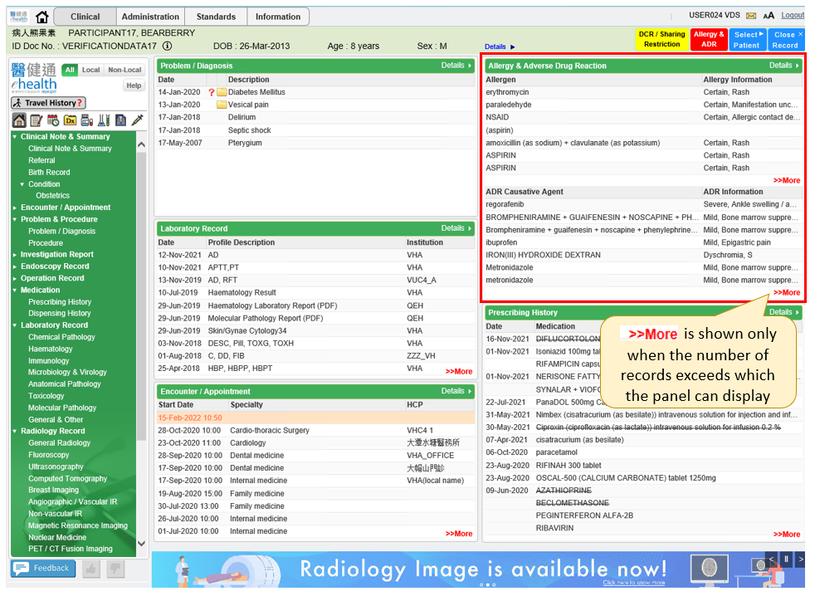

  - In below Detail View, it shows the ADR Causative Agent description, information, reference date and institution.
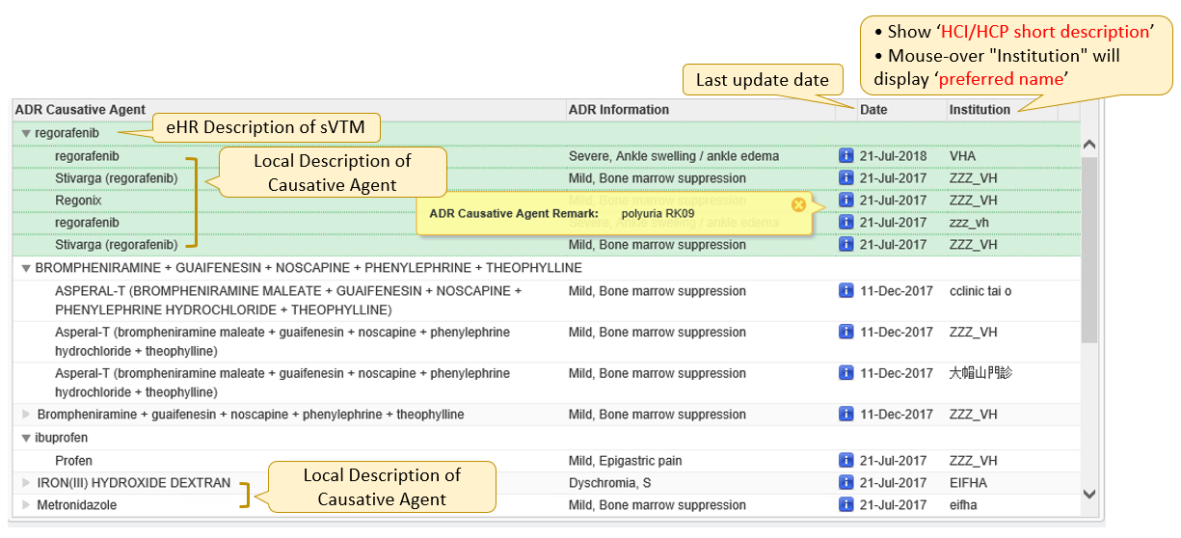
Notations:
Expand arrow for Level 3 data
Dimmed arrow for Level 2 data
Display ADR causative agent remark after clicking it, no label would be shown when no data

  - Filtering for Non-Local HCP (All/Local/Non-Local) will not be applied to ADR data
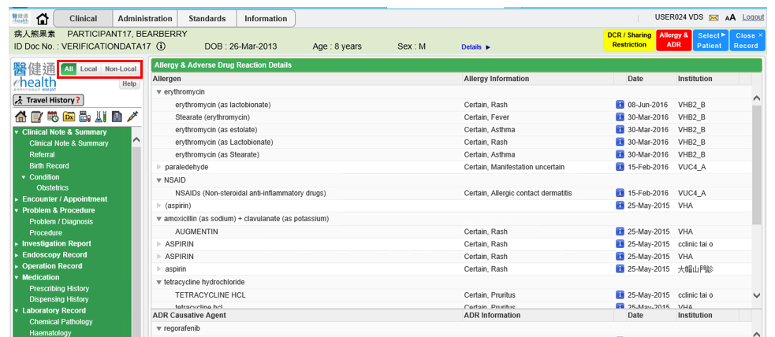

Appendix – Actual Data Values (Sample)

If the actual values entered are various from the test case, please provide actual values as below.
If the value is not inputted, please use [BLANK] to indicate that empty value is inputted intentionally.

